**320 N. LOCUST STREET POINT, TEXAS 75472 PH:903-598-3296 FAX: 903-598-3371**

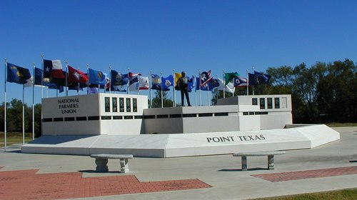**CITY OF POINT**

**Email: cityclerk@cityofpoint.org**

**FENCE-CARPORT-STORAGE-SHED**

**BUILDING PERMIT**

**DATE**:_____________________

**PROJECT ADDRESS**:_____________________________________**ZONING**:_________________________________

**SUBDIVISION**:____________________________**LOT**:__________**BLOCK**:__________________________________

**PROJECT DESCRIPTION**:__________________________________**VALUE**:__________________________________

**TOTAL SQUARE FEET**:______________________**HEIGHT**:_______**LOT SQUARE FEET**:________________________

**APPLICANT**:____________________________________________**PHONE**:_________________________________

**PROPERTY OWNER**:______________________________________**PHONE**:_________________________________

**ADDRESS**:______________________________________________**PHONE**:_________________________________

**GENERAL CONTRACTOR/PROJECT MANAGER**:_________________**ST. LIC**#________________________________

**MAILING ADDRESS**:_______________________________________________**CITY**:____________**ST**:____________

**PHONE**:_______________________**FAX**:______________**EMAIL**:________________________________________

**NOTICE TO APPLICANT:** This permit becomes null and void if work or construction authorized is not connected with 180 days; or if construction or work is suspended or abandoned for a period of 180 days at any time after work is commenced. I have carefully read the complete application and know the same is true and correct. I understand the ordinances governing the construction activity described in this application, and agree to comply with all provisions of the city ordinances, State laws all property restrictions, whether herein specified or not. As the owner of the above property or a duly authorized agent, I hereby grant permission to enter the premises and make all necessary inspections. Permit may be declared void if issued in error.

APPLICANT SIGNATURE:____________________________________________________________________________________

DATE OF BIRTH:_______________________________DL#___________________________________ST:___________________

PERMIT FEE:__________________________________ FEES PAID BY: _____CHECK_____MO_____CASH_____CREDIT CARD

APPROVED BY:________________________________________________DATE APPROVED:_____________________________