**320** **N. LOCUST STREET POINT, TEXAS 75472 PH:903-598-3296 FAX:903-598-3371**

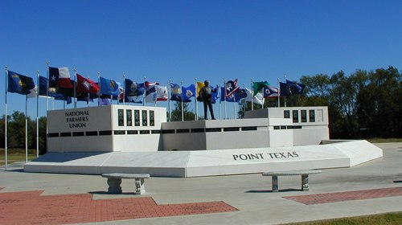**CITY OF POINT**

**Email: cityclerk@cityofpoint.org**

**SIGN PERMIT**

Owner:_______________________________Location:_________________________________

Address:______________________________Phone:___________________________________

Sign Company Name:_________________________ Electrical Contractor:  **Y** **N**

Address:______________________________Name:___________________________________

City:________________________ST:_______Agent:___________________________________

Phone:_______________________________Texas Lic.#________________________________

Sign Co. Lic.#:__________________________Phone:___________________________________

(**Requires City Registration Fee of $100.00**)

**A scaled location drawing is required before issuance of sign permit. Permit fee is based on total square feet of all sides of sign.**

**Square feet per side x number of sides = Total Square Feet**

**Total Square Feet Fee**

Up to 50 sq. ft. $50.00

51 sq. ft. to 100 sq. ft. $75.00

101 sq. ft. to 200 sq. ft. $100.00

201 sq. ft. to 672 sq. ft. $300.00

**Sign Contractor Fee $100.00 Total Fee_________________**

**Notice to Applicant:**

This permit becomes null and void if work or construction authorized is not connected within 180 days; or if constriction or work is suspended or abandoned for a period of 180 days at any time after work is commenced. I have carefully read the complete application and know the same is true and correct. I understand the ordinances governing the construction activity described in this application, and agree to comply with all provisions of the city ordinances, State laws, all property restrictions, whether herein specified or not. As the owner of the above property or a duly authorized agent, I hereby grant permission to enter the premises and make all necessary inspections. Permit may be declared void if issued in error.

APPLICANT SIGNATURE:_____________________________________________DATE:_______________________________________________

DRIVERS LICENSE#:_________________________________________________STATE:_______________________________________________

RECEIVED BY:______________________________________________________APPROVED:_____YES_____NO

PAYMENT TYPE:_____CASH _____CHECK_____MO_____CREDIT CARD