**320 N. LOCUST STREET POINT, TEXAS 75472 PH:903-598-3296 FAX: 903-598-3371**

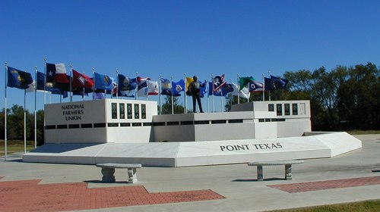**CITY OF POINT**

**Email: cityclerk@cityofpoint.org**

**CHANGE OF ZONING APPLICATION**

Name of Party Making Request:____________________________________________________

Mailing Address:________________________________________________________________

Phone Number:_________________________ Email Address:___________________________

Location of Property involved in request:___________________________________________________________________________________________________________________________________________________________________________________________________________________________________

Lot_________________________Block____________________Addition___________________

Attach Current City Tax Receipt with Application.

Plat of Parcel detailing size, location of utilities, placement and size of proposed structure, location and size of other existing structures.

Nature of Request: (Write request, setting forth type of zoning requested, in shortest, most complete manner. Use back of sheet if additional space is required. Include all information pertinent to the request.)

I understand that it is necessary for me to be present at the City of Point Council Public Hearing.

Signature of Owner:_____________________________________________________________

All plats,etc.., must be filed with the City Secretary at the time this application is filed, with all fees charged by the City paid. Notice will be sent regarding hearing date.

**FOR STAFF USE ONLY_____________________________ Fee: $100.00 per lot**

**Date Received:______________________ Fee Received: _____YES_____NO**

**PAYMENT TYPE :_____CASH_____CHECK_____MO_____CREDIT CARD**